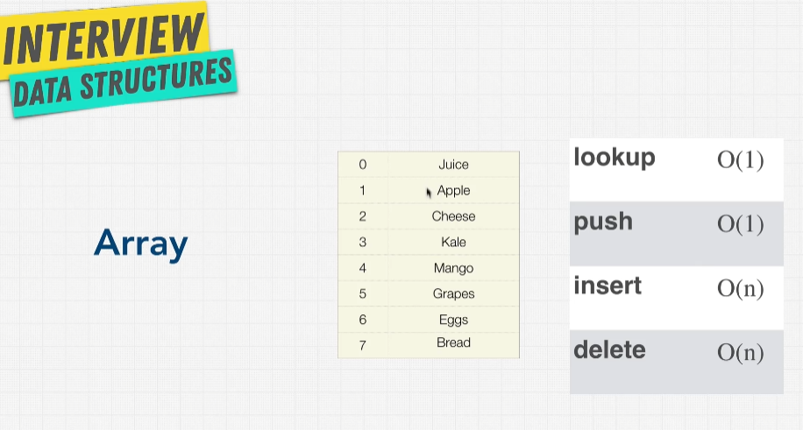

Static & Dynamic Array

1. Static Array is fixed in size
2. Dynamic array allows us copy and create new array for new allocation, dynamically adjust to size and memory we need

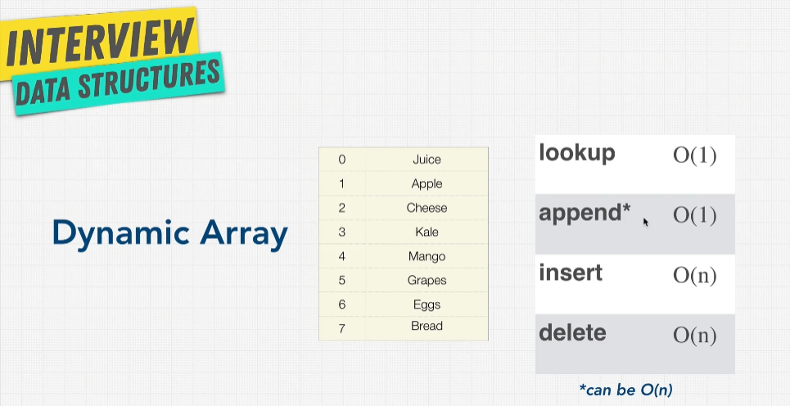In JS, append works copy the array entirely to other memory then only do the adding element. So here memory could take place and could possible O(n)

When to use arrays

